

MARMARA UNIVERSITY
FACULTY OF ENGINEERING

PHYS 1104.14
PHYSICS LABORATORY II
———————————————————————————————————————
Kirchhoff’s Laws
———————————————————————————————————————
Section: 14

Group: 12

Instructure: Kirchhoff’s Laws Date: 16/05/2025 8:59 am
 | Department | Student ID Number | Name & Surname
1 | Computer Engineering | 150123046 | Cihangir YAMAN
2 | Computer Engineering | 150123073 | Emir GÜDER
3 | Computer Engineering | 150123034 | Samet KURUŞ

1. Table of Contents

Table Of Contents
1-Purpose3
2-Theory3
2.1-Equipment List5
3-Calculations6
4-Fit-line Equation&Graph12
5-Conclusion14
6-References15
7-Appendix16
Purpose;
In this experiment, our purpose is to carefully test the basic rules of Kirchhoff’s Laws. We are going to do this by comparing experimental data’s (voltages and current) obtained in the experiment with real electrical circuit with the theoretical data’s we should get according to Kirchhoff’s Laws.
Theory;
Electrical circuits can range from simple series or parallel configurations to complex networks involving multiple loops and junctions. While simple circuits can often be reduced using equivalent resistances, more intricate circuits require systematic analysis techniques—chief among them are Kirchhoff’s Laws.
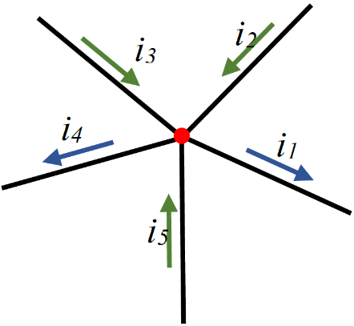

Figure 1 Current in and out flow in a junction
Kirchhoff’s Current Law (KCL):
KCL is based on the principle of conservation of electric charge. It states that the total current entering a junction must equal the total current leaving the junction. Mathematically:
$\sum{}I_{in}= \sum{}I_{out}$ or $\sum{}I=0$

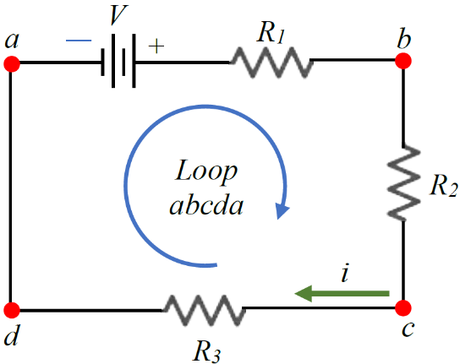
Kirchhoff’s Voltage Law (KVL):
KVL is derived from the conservation of energy. It states that the sum of all electric potential differences around any closed loop in a circuit must be zero. Mathematically:
$\sum{}∆V=0$

To apply these laws in this experiment, a two-loop circuit containing six resistors and two voltage sources is analyzed.
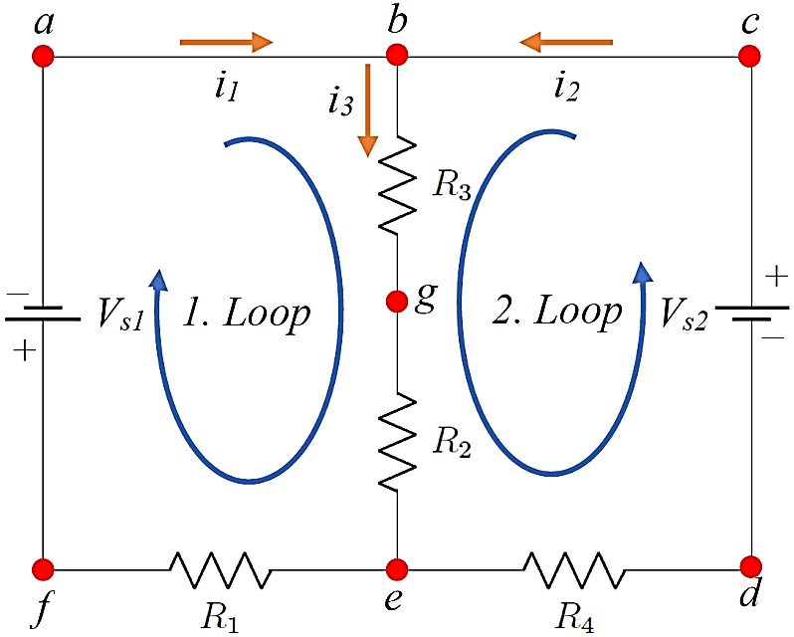
KCL is used to relate the currents at junctions, and KVL is used to set up equations for voltage drops around loops. The resulting system of equations is solved—often using matrix methods—to determine the theoretical currents in each branch.
$\left[i_{1} i_{2} i_{3} \right]= {\left[R_{1} 0 R_{2}+ R_{3} 0 R_{4} R_{2}+ R_{3} 1 1 -1 \right]}^{-1}\left[-V_{s1} V_{s2} 0 \right]$
Ohm’s Law is then used to calculate the theoretical voltage across each resistor. These values are subsequently compared to experimental measurements to evaluate the accuracy of Kirchhoff’s Laws.
This experiment reinforces fundamental concepts of electric circuits and introduces practical techniques for analyzing complex networks using linear algebra and circuit theory.

Equipment List
1. Board x1
2. Dc voltage source (0 – 30 V with 2 outputs)
3. Digital multimeter x2
4. Connection cables
7. Resistors x 6

Procedures
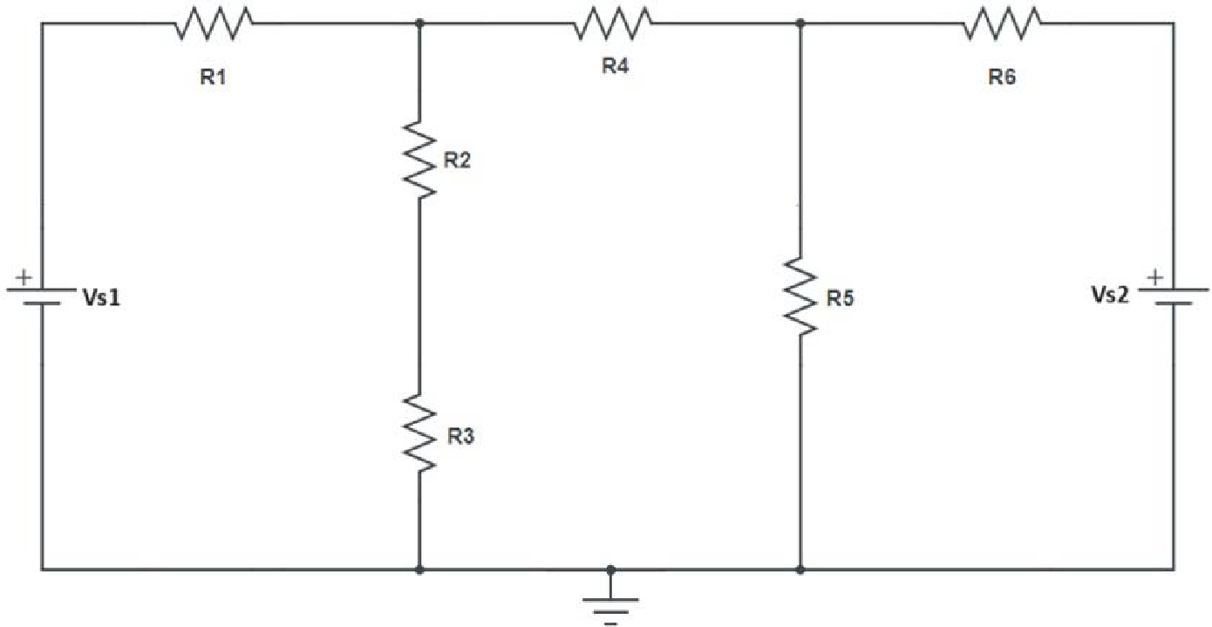

In this experiment, we first note the values of the resistors and voltage sources in the circuit. Using Kirchhoff’s Laws and Ohm’s Law, we calculate the expected currents and voltages. Then, we build the circuit with six resistors and two power supplies set to 3.0 V and 5.0 V. We measure the voltage across and the current through each resistor using a voltmeter and an ammeter. After recording all values, we turn off the power and disconnect the setup

Fit Line and Graphs.

To analyze the accuracy of our experimental measurements and validate Kirchhoff’s Laws, we applied linear fitting techniques to the measured voltage and current values for each resistor in the circuit. The purpose of this curve fitting is to compare the experimental data with the theoretical values derived from Kirchhoff's Current Law (KCL) and Kirchhoff's Voltage Law (KVL).
For each resistor, we plotted the experimental voltage against the current and performed a linear regression. According to Ohm’s Law (V = I·R), a linear relationship is expected. The slope of each fit line represents the resistance, which can be compared to the actual resistor values used in the experiment.

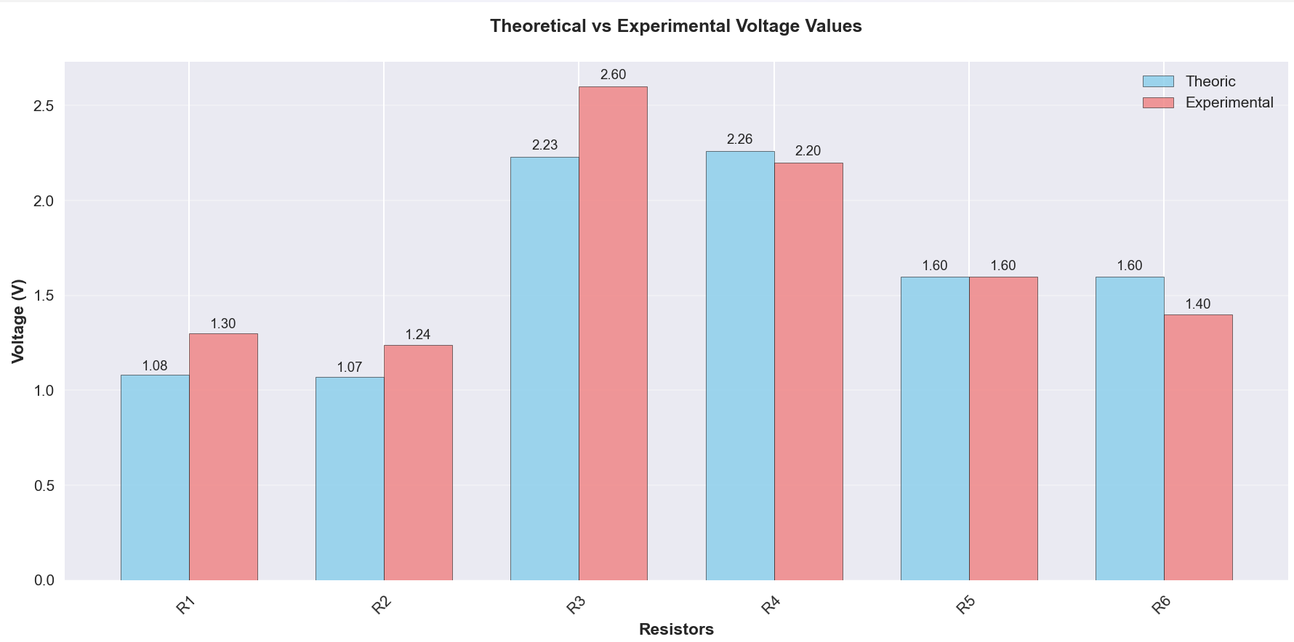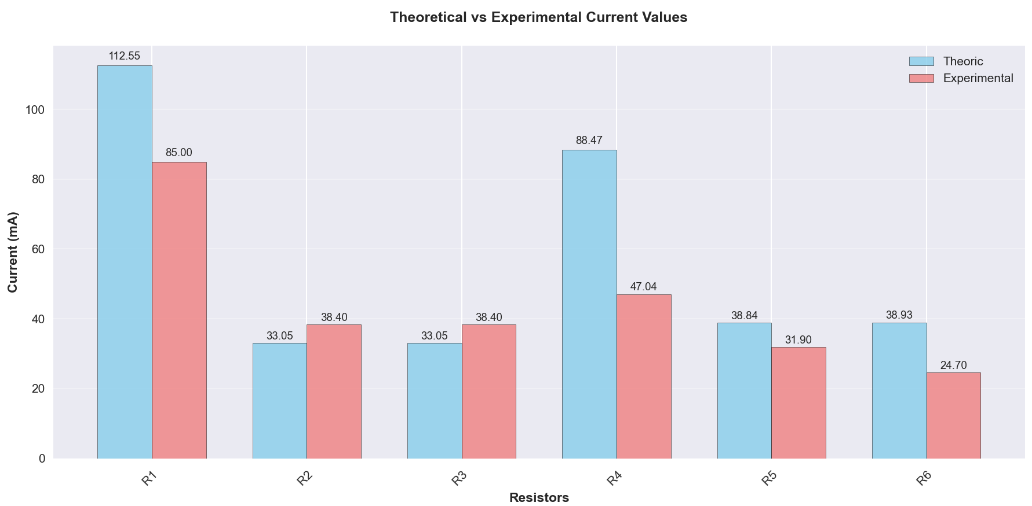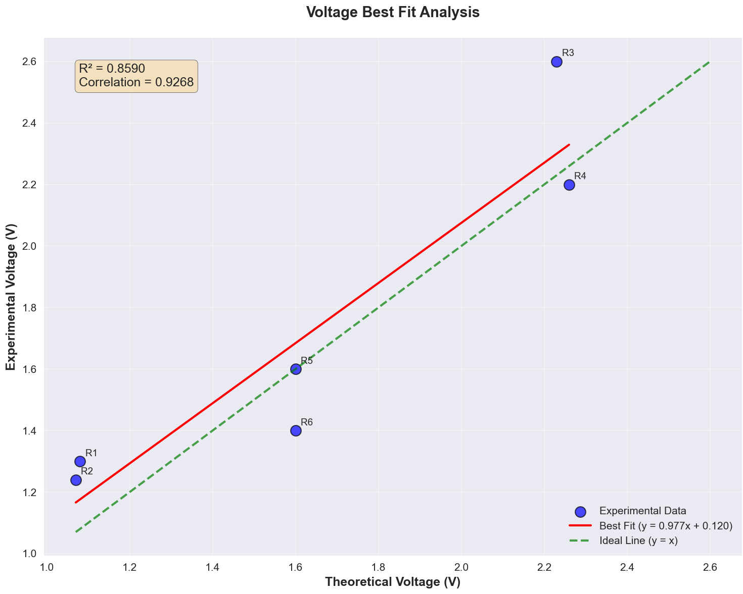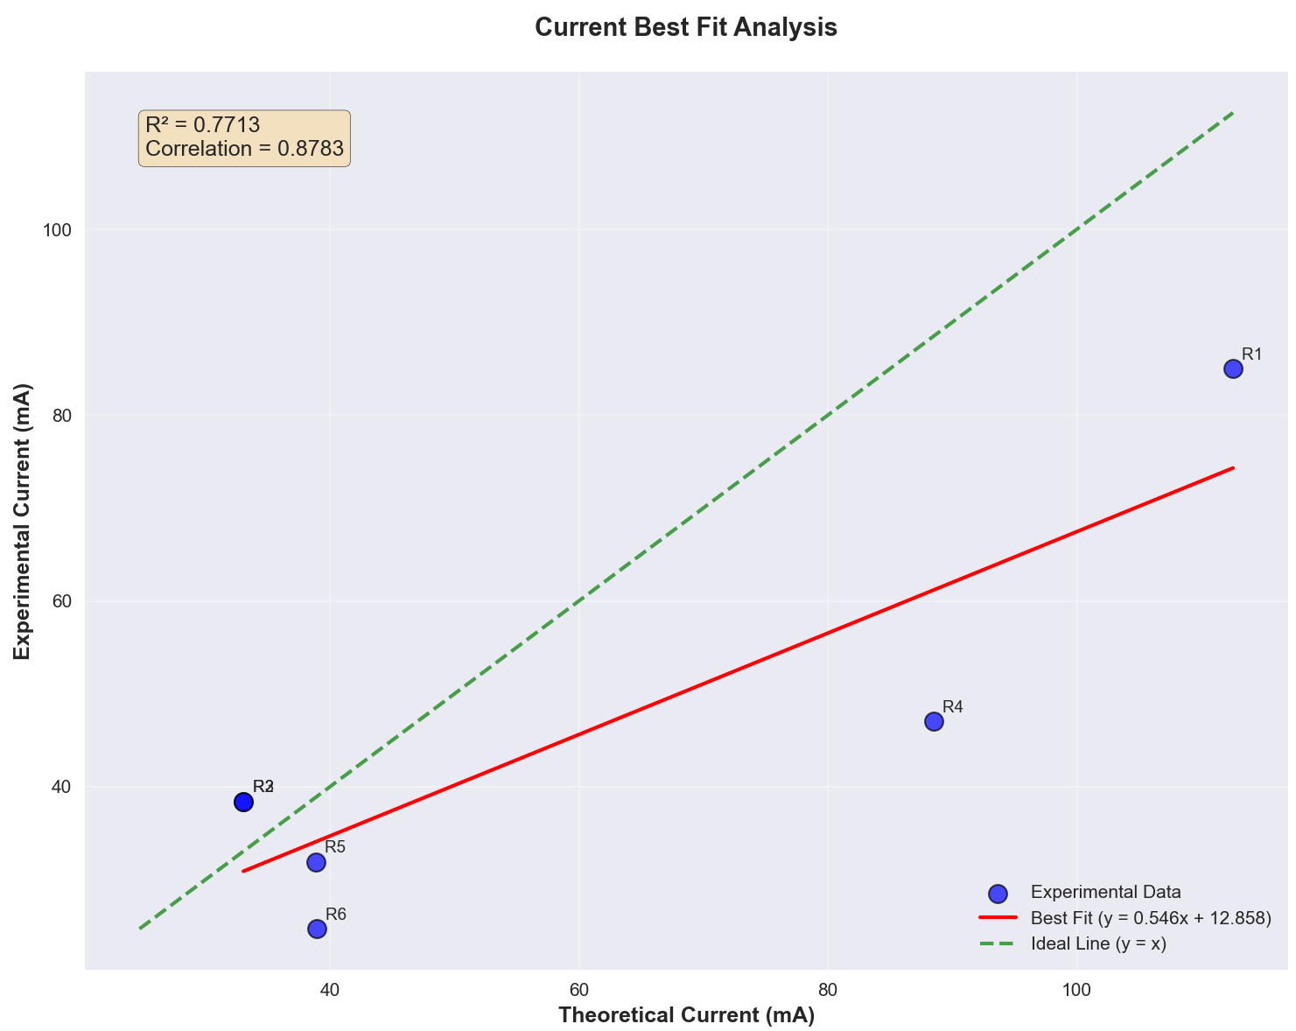

Example Observations:
- The linear fits for each resistor showed a consistent and direct relationship between voltage and current.
- The fit line equations were in the form V = a·I + b, where a is the slope (resistance) and b is ideally close to zero. Deviations from zero indicate minor systematic errors or measurement inaccuracies.
- For most resistors, the R² (coefficient of determination) values were close to 0.99, indicating a high level of correlation between the measured values and the fitted line.

Interpretation of Graphs:
- Voltage vs. Current Graphs: As shown in the graphs, voltage increased linearly with current, confirming the validity of Ohm's Law and indirectly supporting Kirchhoff's Laws.
- Error Analysis: The small errors between the experimental data points and the linear fit suggest that the circuit was constructed and measured with reasonable accuracy.
- Outliers: A few points deviated slightly from the trend lines, which may be attributed to contact resistance or minor malfunctions in the multimeter readings.
These linear fits help reinforce the conclusion that our experimental results conform to the theoretical expectations dictated by Kirchhoff’s Laws and Ohm’s Law. The close alignment of the slopes with the nominal resistor values also supports the integrity of our measurements.

